Login to the Azure portal: <http://manage.windowsazure.com>

Click New -> Compute -> Virtual Machine -> From Gallery.

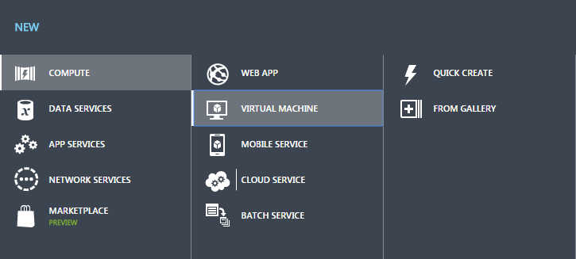

Select SQL Server 2012 SP2 Standard, and click Next.

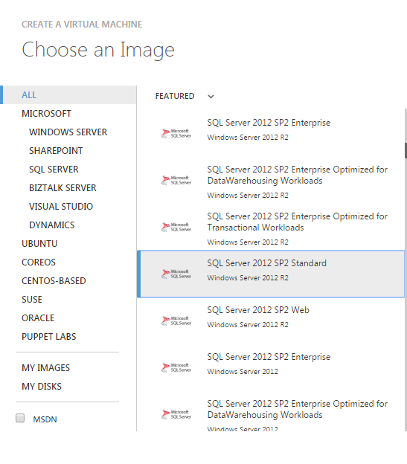

Enter a name for your virtual machine.

Select the Basic tier, and select A2 (2 cores, 3.5GB memory) Size.

Enter a username and password. Remember these details, you will need them to log in.

Click Next.

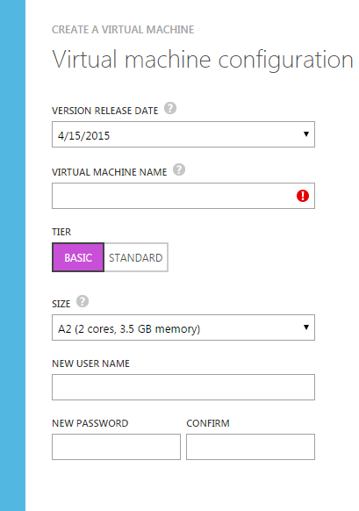

Select “Create a new cloud service”.

Enter a name for your cloud service. This name will make up the URL for your service (http://<cloudservicename>.cloudapp.net).

Select Australia East for the Region.

Select “use an automatically generated storage account” for Storage Account.

Select (None) for Availability Set.

Under Endpoints, change the Public Port for Remote Desktop to 443. This will allow you to remote desktop to your virtual machine through the UTS firewall.

Create a new Endpoint entry. Select HTTP, the protocol, public port, and private port should populate automatically.

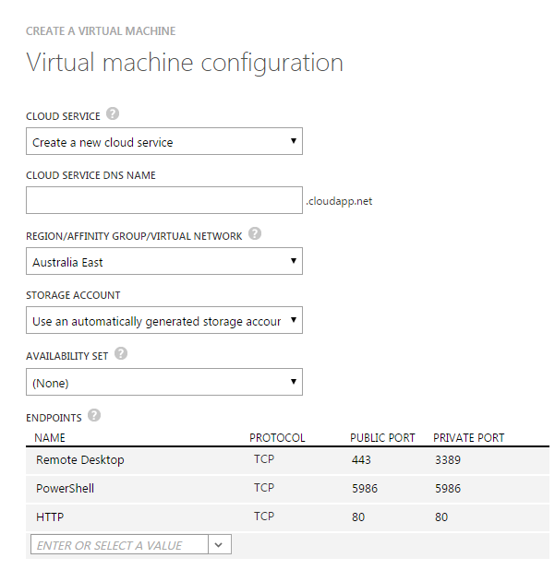

Click Next.

Check “Install the VM Agent” and click the Tick button.

The virtual machine will now be provisioned. Once it has completed, click on the Connect button to download your RDP file.



Open the downloaded RDP file and then log in with the credentials you set earlier.

Open up Server Manager.

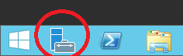

Go to Dashboard -> Add roles and features.

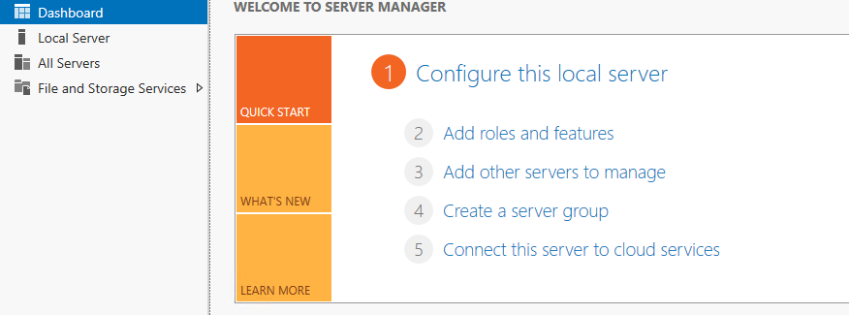

Click Next until you reach the Server Roles page.

Check Application Server.

Check Web Server (IIS) -> click Add Features.

Click Next

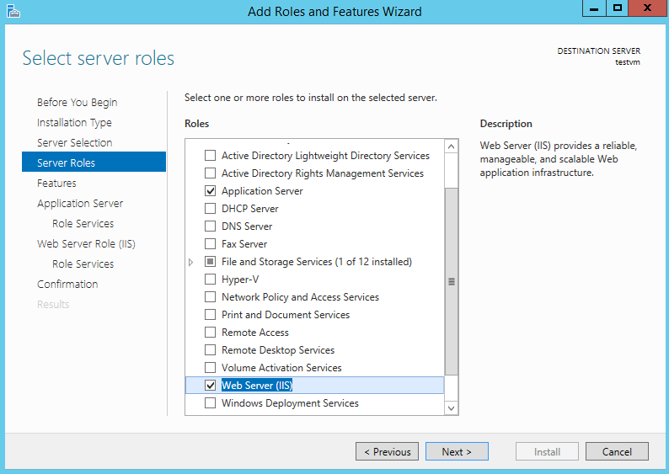

Click Next until you reach the Application Server -> Role Services page.

Check Web Server (IIS) Support -> click Add Features.

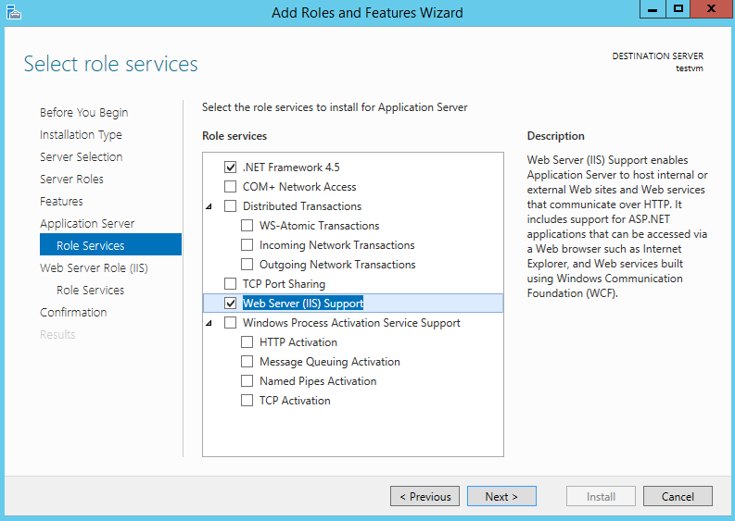

Click Next until you reach the Confirmation page and then click Install.

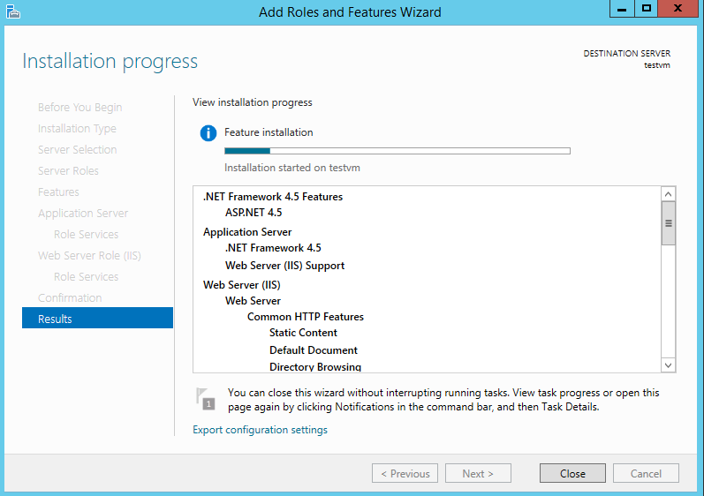

Wait for the installation to complete and then click Close.

Copy “DbSetup.zip” to your VM and extract the contents somewhere.

Click the Start button and open SQL Server Management Studio.

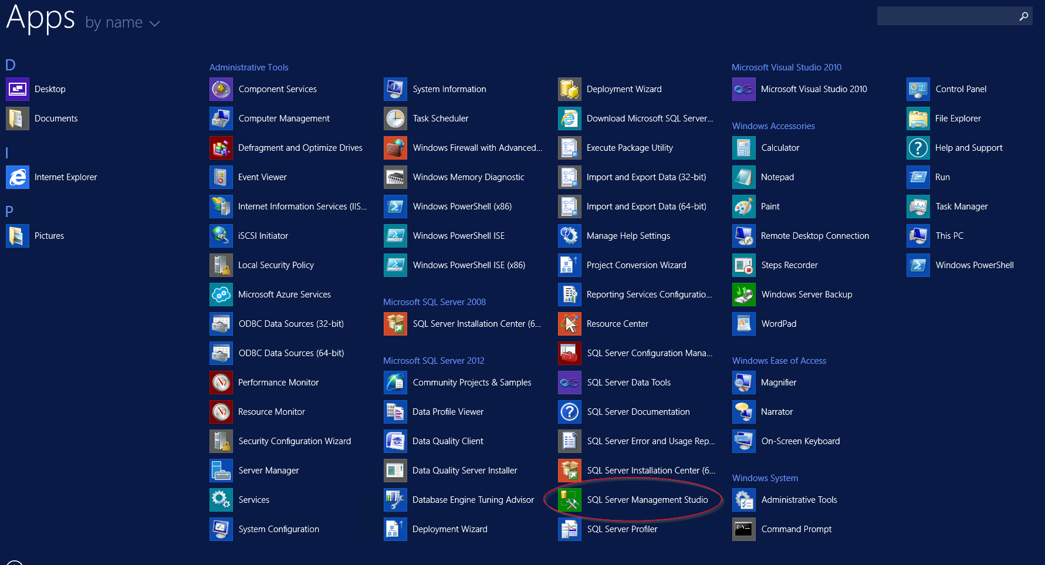

Click Connect.

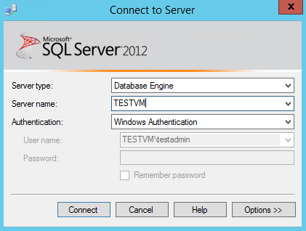

Right-click on Databases and click New Database.

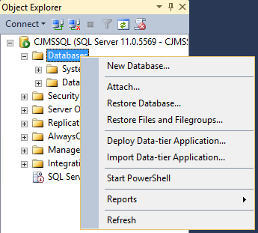

Use “Database name”: elssa_booking. Click OK.

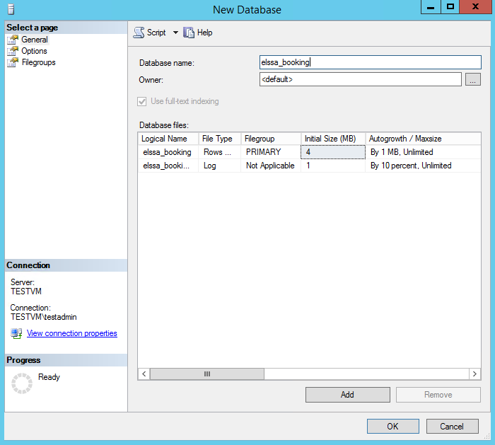

Go to File -> Open -> File. Find where you extracted “DB Setup.zip” and open “Tables_1.sql”. Click Execute and wait for the query to complete execution.

Repeat the above step for “Tables_2”, “Tables_3”, “Tables_4”, and “Tables_5”, and then run “StoredProcedures.sql” and “SetupUser.sql”.

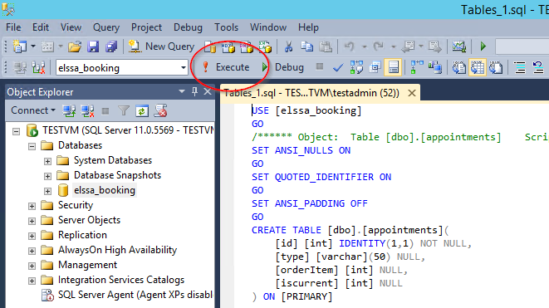

Right-click on your server name and click Properties.

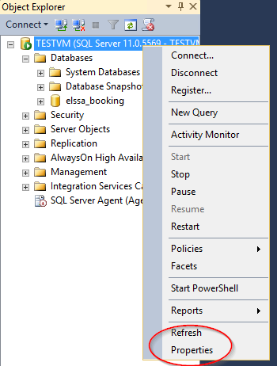

Go to Security and click “SQL Server and Windows Authentication mode”. Click OK.

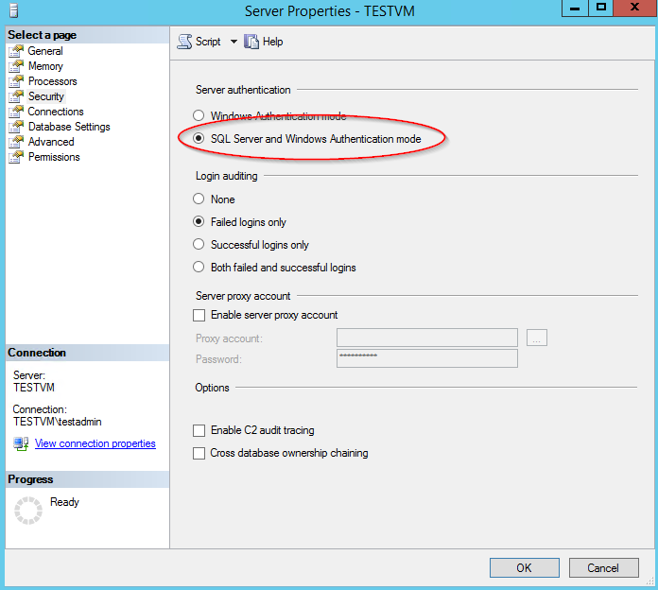

The SQL Server needs to be restarted for this change to take effect. Click Start -> Services.

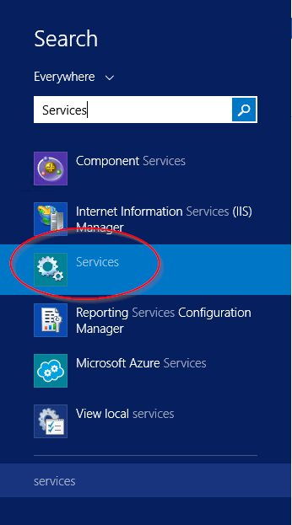

Right-click on “SQL Server (MSSQLSERVER)” and click Restart.

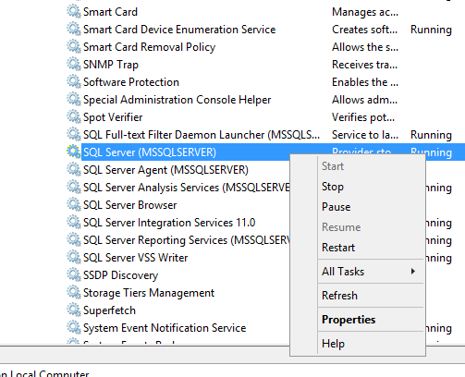

Go to C:\inetpub\wwwroot and delete all files in this folder.

Copy “WebDeploy.zip” to your virtual machine and extract the contents into C:\inetpub\wwwroot

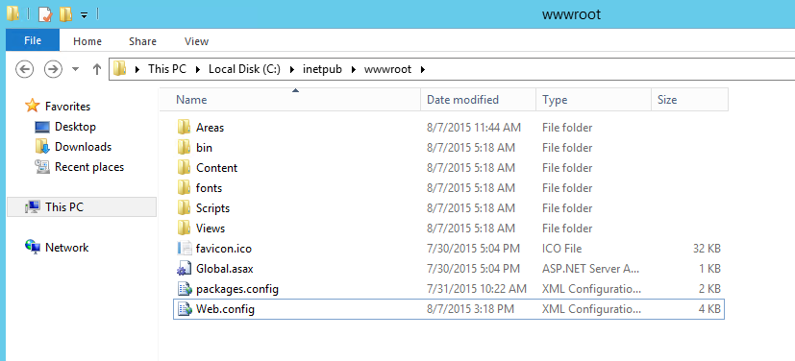

Your services should now be online. Go to http://<cloudservicename>.cloudapp.net, you should see a default web page appear.

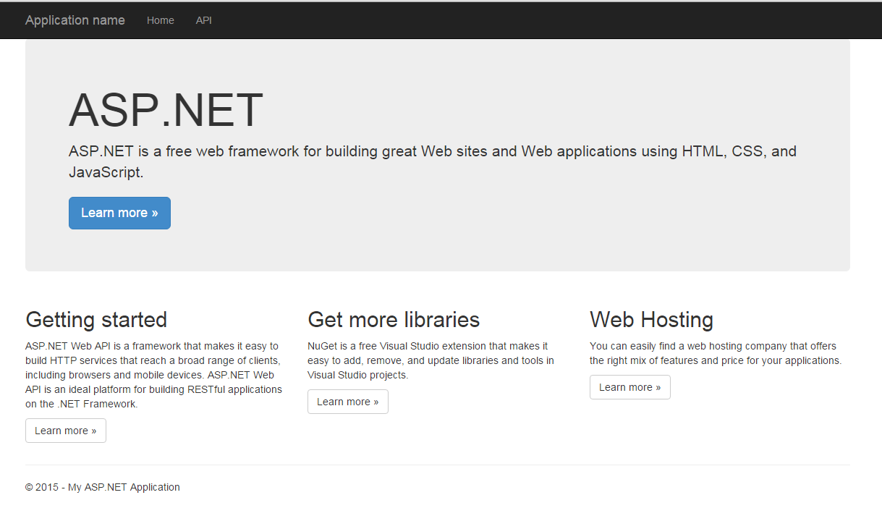

The final step is to configure your application key. Open C:\inetpub\wwwroot\Web.config in a text editor and find “ApplicationKey” under the <appSettings> node. Change this value and save the file.

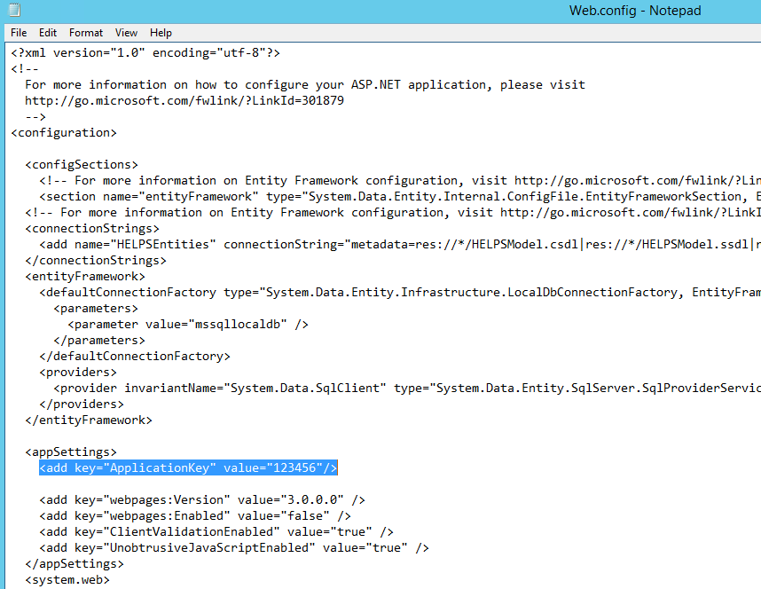

This key should be included in each request to the services under the request header “AppKey”. If this header is not included, or the incorrect application key is sent, the request will not be processed by your services.

